Instructions for updating f2b.
Register the new version with your sponsoring bank
The new software has a new SFP number and will need to be registered with
your sponsoring bank before you can use it.
The phone number of your sponsoring bank should be listed on our web site here:
http://www.elseware.org.uk/24.html
The bank will require the following details:
BACS | Company | elseWare ltd
 | Product | f2b
 | Version | 2.0
 | SFP Number | 9715
Faster Payments | Company | elseWare ltd
 | Product | f2b
 | Version | 2.0
 | SFP Number | 1854
Shared database
If you have a shared database ( i.e. more than one copy of f2b connected on a database on a server ) then please be aware that the first updated instance of f2b will apply changes to the database which may cause other instances of the software to stop working. If you update one instance of f2b, you will need to update ALL the instances of f2b connected to that database.
Timing
Please give yourself as much time as possible. Choose the quietest time of the week or month to apply the update so that there is time to correct any problems that may arise.
Update to SQL Express to 2014 or 2016
Ideally, if you are running SQL Express lower than 2008 R2, you should update to a more recent version.
Please visit the Installing SQL Server page on the elseWare web site.
Download f2b Update Program
Open Windows Explorer and check if you have a folder called f2b on the C:\ drive.
If you do not have a folder c:\f2b, then you should create one.
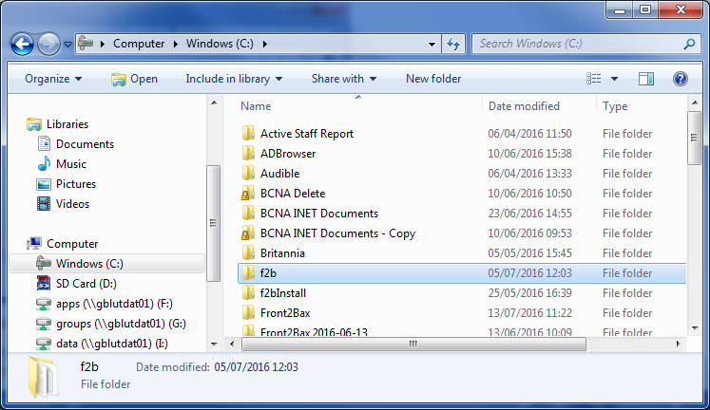
Click on the link below ( or paste it into the top of a browser )
ftp://home67108423.1and1-data.host
The username and password are as follows:
username = u33767836-f2b
password = elseWare
You should locate the file InstallBAX.exe, right click on it and select Save Target As ( Save Link As if you’re using Chrome )
Save the file when asked to the folder c:\f2b

Run Install f2b.exe
Once it has been downloaded, locate the file C:\f2b\InstallBAX.exe and double click on it to run it.
Click on Update existing copy of f2b and then press Next.
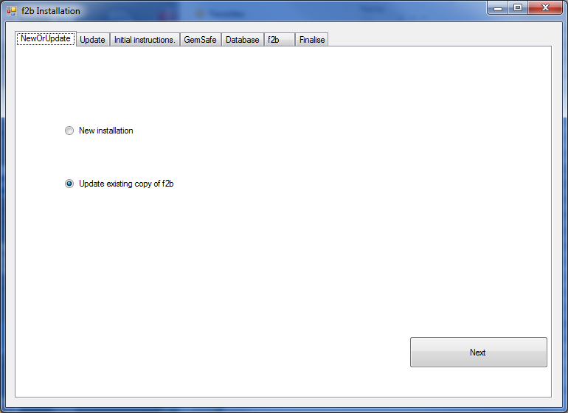
The program will automatically upgrade your f2b software.
If you see any error messages then please take a screen shot ( hold down the Alt key and press PrtScrn, then paste the result into a word document or email ), and then email it to support@elseware.org.uk

PLEASE NOTE
A new error level has been introduced to show Minor Warnings that probably do not need to be investigated.
The hierarchy of submission statuses before transmission is now as follows:
Icon | Status | Meaning
 | OK | No errors were detected in the file.
 | Minor Warning | Data in the submission has been altered, but probably does not need to be checked. Altered data can include padding short account numbers with leading zeros, updating past processing dates to the next available BACS processing date or replacing invalid characters with a full stop (e.g. O’Connor becomes O.Connor)
 | Warning | The submission contains data that should be checked, e.g. a Sort Code that is not in the ISCD, or an Account Number that has failed Modulus checking.
 | Error | There is a severe error in the data and the submission cannot be sent until the error is rectified
Ensure that the entry for Path to current f2b folder is correct.
Your program may be installed in the folder c:\Program Files\f2b rather than C:\f2b.
By preference the new instance of f2b should be installed in C:\f2b
When the path is correct please press the Update button
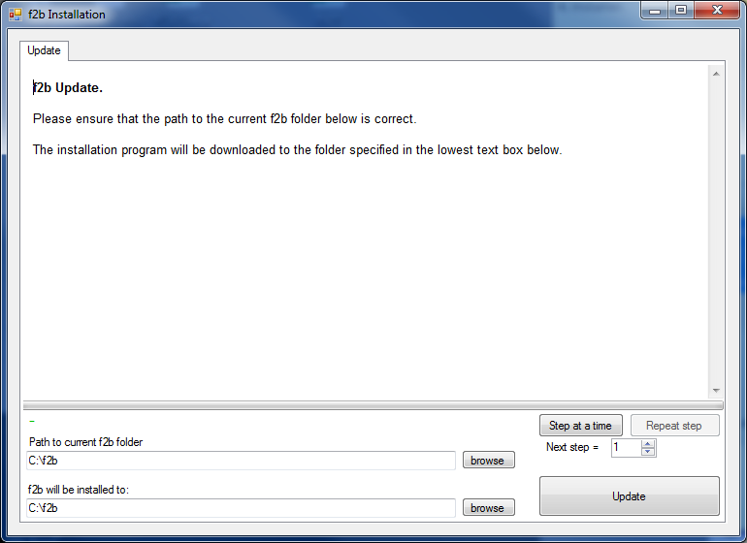
When the program has completed your copy of f2b will have been updated.
If you receive any error messages during the installation please take a screen shot ( press the Ctrl and PrtScrn keys simultaneously ) and email it to support@elseware.org.uk

